30th May 2016

**Lopez dominates at WTCC Race of Germany**

Jose Maria Lopez was the biggest winner during the dramatic weekend racing at the legendary Nurburgring. The Citroen works driver and current Champion, took the opportunity of a dramatic opening race last lap crash, which forced Honda’s Tiago Monteiro and Yvan Muller out of the race.

Monteiro had been leading from pole, with Muller not far behind, and Lopez who started from the grid in P9 in hot pursuit.

Climbing positions from behind, Muller tried to overtake Monteiro at the end of the second lap, but the Honda driver kept in front as Muller briefly got two wheels on the grass. Unfortunately for Monteiro, he went off the track, whilst leading on the final lap and actually hit the barriers hard and ended up in the middle of the track. Muller who was closely following had no room to manouvre and made contact with the Portuguese, which enabled Lopez a small gap to get in front.

Tom Chilton also benefitted from the situation and took second place with only around half a second behind Lopez. Norbert Michelisz completed the podium for Honda in third and Rob Huff finishing in fourth. The German lady driver Sabine Schmitz took P10 on her return to WTCC action at her home circuit.

The main race also saw Jose Maria Lopez reaching the top spot in the podium by winning ahead of the very competitive Norbert Michelisz. The Hungarian Honda driver, made a better start than pole-man Lopez to take the lead down the inside of the first turn. However Lopez was quick to respond and started dominating. Towards the end of the race, Michelisz managed to recover a lot of ground and followed closely with less than half a second difference from Lopez.

For his part Tom Chilton was once again making good points for his hopes and aspirations to become the top WTCC Trophy driver managing a meritorious third place, with the other Briton, Rob Huff after him.

Mehdi Bennani also managed to pass Nicky Catsburg and finished fifth.

**FIA WTCC Current Driver Standings:**

1. Jose Maria Lopez 193

2. Tiago Monteiro 124

3. Rob Huff 122

4. Norbert Michelisz 120

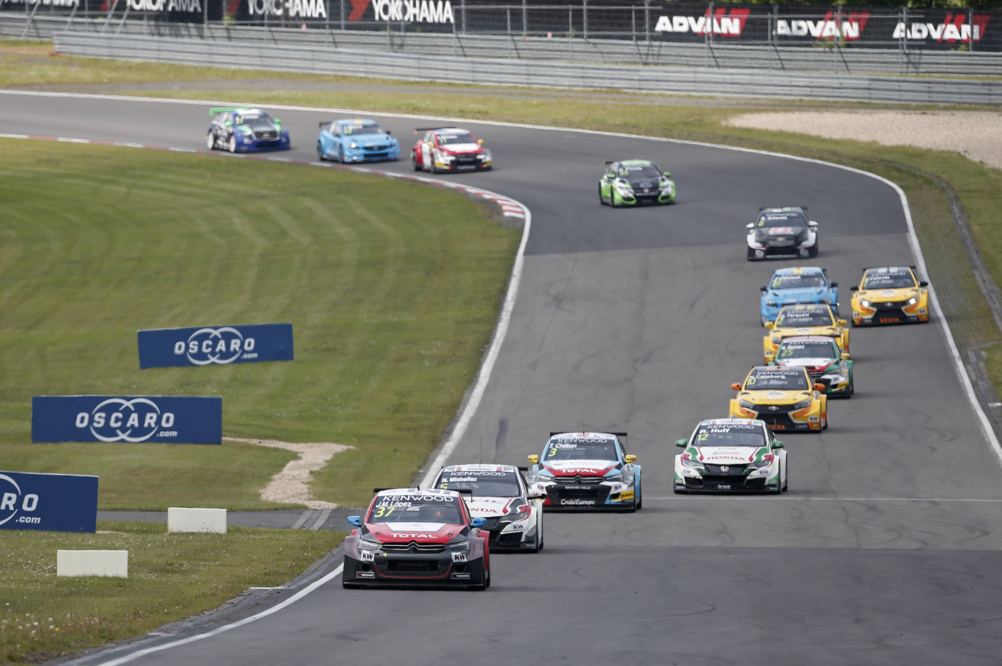

*Lopez Leads at the Green Hell*

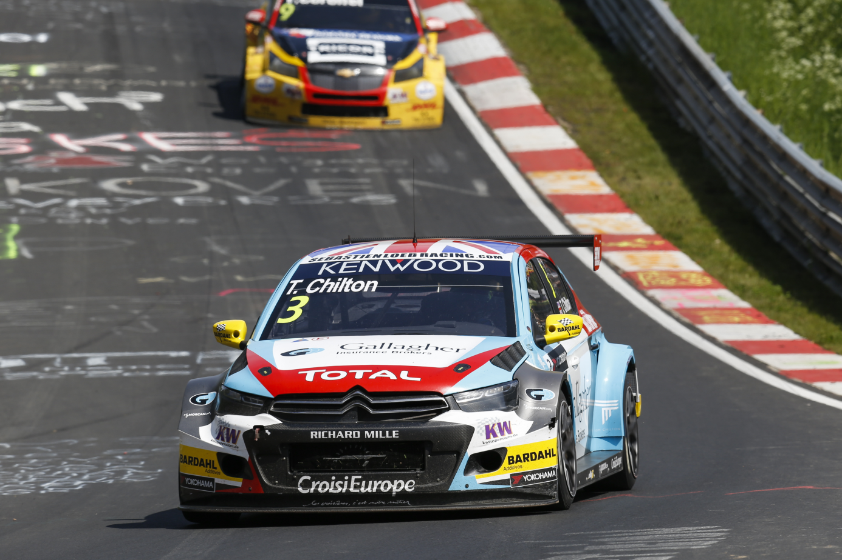

*Valuable points for Tom Chilton*